Exercice 03 Insertion d’une figure
Utilisez l’image qui se trouve un peu plus bas dans cette page. Déplacez l’image pour l’amener entre les deux paragraphes de texte. Centrez l’image. Au-dessous, insérez la légende suivante : Fig. 3. Reasons for liking sites. L’image et la légende doivent être centrées.
By far the most common type of reason students gave for liking a site was its function or content. For example, search engines were valued for being able to find information, email sites for offering communication, other sites because the content was interesting or useful. Between them, reasons associated with content and function were more common than all other kinds of reasons combined (see Figure 3).
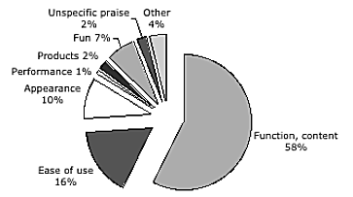
Fig. 3. Reasons for liking sites.
The next most frequently-given reason was ease of use. This reason was most often associated with a search engine. Aspects of the appearance of the site occurred quite frequently across all types of site. Colour and layout were the most common attributes mentioned, followed by graphics and pictures. Fun seemed also to be an important factor; most of the reasons in this category involved activity/interactivity or humour. Very few students cited fast or efficient performance as a reason for liking a site.

